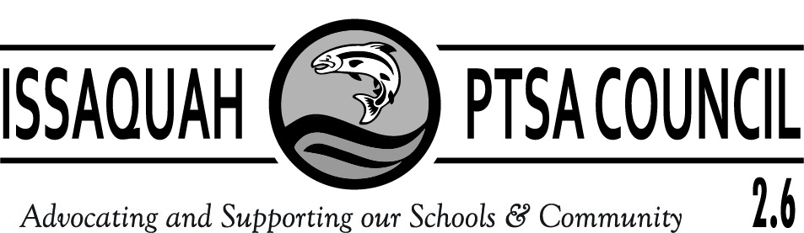

ISSAQUAH PTSA COUNCIL 2.6
COUNCIL FEES AND DONATIONS
2023 – 2024 SCHOOL YEAR

Attention Treasurers: This form details billing and Instructions for Council Fee and Donations Submissions due Oct. 31, 2023

- Issaquah PTSA Council assessment fee is collected only in October. **Note, dues for local PTAs/PTSAs will be $150.00 at all levels for this year (COVID-19 Special again for 2023-2024, it is anticipated that Dues will go back to typical for 2024-25).

      - Elementary Schools $200.00
      - Middle Schools $200.00
      - High Schools $200.00
      - District Wide $200.00

- ParentWiser (Parent Ed) $250 Minimum per PTA/PTSA. If your PTA/PTSA budgeted more than $250 to support our new ParentWiser program, please remit the amount you have budgeted.

Make checks payable to ISSAQUAH PTSA COUNCIL 2.6 for the total of your Council fees and donations. Please be sure the check has 2 signatures!

Submit your check for the following grand total:

  - Council Fee ______$200.00 _
  - Parent Ed __+__ 250.00__ _
  - Grand Total __=__ $450.00____

PTA/PTSA Name ___________________________

- Please mail check and this form NO LATER THAN OCTOBER 31, 2023 to:

Issaquah PTSA Council
c/o Nikki Mason
15017 253rd Ave SE
Issaquah, WA 98027

Thank you for your prompt payments!
If you have any questions, please contact Council Treasurer,
Nikki Mason, treasurer@issaquahptsa.org or 504-390-0274

Attention Treasurers: This page is for your invoice/record.

- Dues for local PTAs/PTSAs will be $200.00 at all levels for this year (COVID-19 Special again for 2023-24, it is anticipated that Dues will go back to typical for 2024-25).

      - Elementary Schools $200.00
      - Middle Schools $200.00
      - High Schools $200.00
      - District Wide $200.00

- ParentWiser (Parent Ed): Each year, each local unit contributes to the funding of the Council’s district-wide parent education programs and transition seminars. Each PTA/PTSA should have a line item in their budget for this fee of $250 minimum. Please contact the Council Parent Ed Chair Heidi Fuhs with any questions regarding this program at parent-ed@issaquahptsa.org

- Total Amount Submitted to Issaquah Council PTSA by October 31, 2023

= __$450.00__

