http://static.wixstatic.com/media/41d000_e46aa87d6b7609392f5abce1f5c47645.png_srb_p_65_60_75_22_0.50_1.20_0.00_png_srbhttp://static.wixstatic.com/media/41d000_e46aa87d6b7609392f5abce1f5c47645.png_srb_p_65_60_75_22_0.50_1.20_0.00_png_srb Winter Break

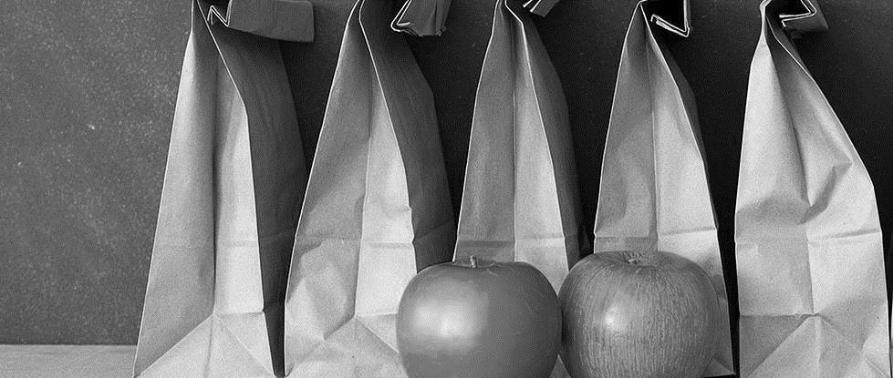 LUNCH for the BREAK

____________

**Registration opens Nov. 1!**

**Register online or at the Issaquah Food & Clothing Bank**

____________

**Renton, Klahanie and Issaquah pick up/drop off locations available**

____________

Free Food Box

**Breakfast, lunch and snack foods for Winter Break.**

**Many families need help during school breaks - register to receive a box or donate today!**



Donor drop off: Monday, Dec. 18 2-7pm

Family pick up: Tuesday, Dec. 19, 2-7pm

Proudly serving all schools in the Issaquah School District

Visit Us Online At

**www.lunchforthebreak.com**

Or Contact Us for More Info

**lunchforthebreak@gmail.com**