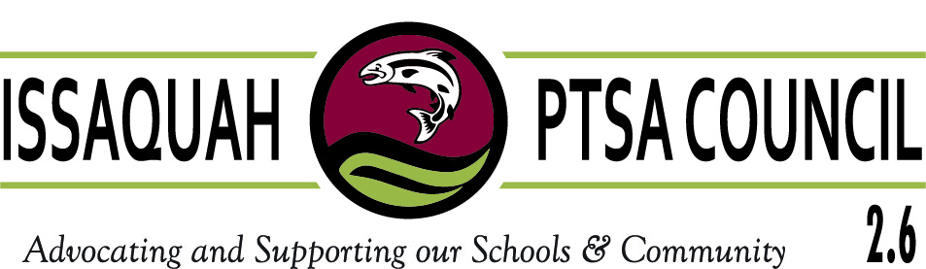

Issaquah PTSA Council 2.6
Voting Delegates Form

According to the Uniform Bylaws of the Washington State PTSA, the membership of a Council consists of the PTAs/PTSAs in its district. The voting delegates of a Council shall consist of the Council Board of Directors, the Local Unit President and three (3) authorized delegates, two (2) of which may be represented by alternates. PTAs/PTSAs of the Issaquah PTSA Council must file the names of the four (4) authorized delegates and the two (2) authorized alternates prior to the second General meeting.

Co-Presidents should be aware that the President’s position has ONE vote. The other Co-President should be listed as one of the authorized delegates. Members of the Council Board of Directors already have a vote at the Council meetings, so they should not also be listed as a PTA/PTSA voting delegate.

A PTA/PTSA should not file the name of a person who is a voting delegate for another PTA/PTSA. Each person has only ONE VOTE, regardless of how many positions that person may hold in PTAs/PTSAs or Council.

VOTING DELEGATES:

1. (President) _____________________________________________________
2. ______________________________________________________________
3. ______________________________________________________________
4. ______________________________________________________________
1st Alternate: _____________________________________________________
2nd Alternate: _____________________________________________________

_________________________________ ___________________________
Signature of Submitter Position

Date: ___________________

Due by October 12, 2017 to Council Secretary

