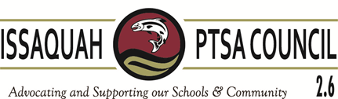
Issaquah PTSA Council Membership Meeting ISD Admin B & C March 9, 2017
AGENDA
9:30-9:35 Welcome

9:35-9:45 President’s Report Becky Gordon

9:50-10:00 Business
Minutes Leslie Kahler
Financials Laila Collins
Nominating Committee Ina Ghangurde & Heidi Fuhs

10:00-10:15 Awards Presentation Awards Committee

10:15-10:30 Breakout – Conflict Resolution
Vice Presidents Kimberly Nocco, Alisa George, Care Maree Harper,
Kym Clayton, Ina Ghangurde

10:30-10:40 WSPTA
Best Practices Kym Clayton & Alisa George (2)
Membership Erin Eaton (5)
Advocacy Korista Smith-Barney (3)

10:40-11:00 Committee Reports
Art in the Schools Juliette Ripley-Dunkelberger
Laurelle Graves
F.A.C.E. Margarita Leas
Ina Ghangurde
Healthy Youth Initiative Pat Castillo (5)
Issaquah Schools Foundation Valerie Yanni (5)
Outreach Kim Weiss (3)
Parentwiser Heidi Fuhs (3)
Debbie Steinberg-Kuntz
Reflections Leah Gibson
STAR/Special Ed Carrie Hipsher
VIS Dawn Peschek (3)
Webmaster/Directory Cindy Kelm

11:00-11:20 District Updates Martin Turney, Executive Director of Operations
Doug Jones – IEA

11:20-11:30 New Business

Adjourn

Upcoming Training:
WSPTA Convention April 27-30, 2017 SeaTac Hilton

