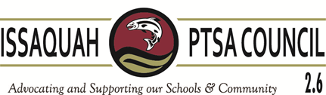
Issaquah PTSA Council Membership Meeting ISD Admin Board Room January 12, 2017
AGENDA
9:30-9:35 Welcome

9:35-9:50 President’s Report Becky Gordon
Training Survey Monkey

9:50-10:05 Business
Minutes Leslie Kahler
Financials Laila Collins
Golden Acorn & Awards Dawn Peschek

10:05-10:20 Breakout
Vice Presidents Kimberly Nocco, Alisa George, Care Maree Harper,
Kym Clayton, Ina Ghangurde

10:20-10:35 WSPTA
Best Practices Kym Clayton & Alisa George (10)
Membership Erin Eaton (3)
Advocacy Korista Smith-Barney (2)

10:35-10:50 Committee Reports
Art in the Schools Juliette Ripley-Dunkelberger
Laurelle Graves
F.A.C.E. Margarita Leas (5)
Ina Ghangurde
Healthy Youth Initiative Pat Castillo (2)
Issaquah Schools Foundation Valerie Yanni
Outreach Kim Weiss (3)
Parentwiser Heidi Fuhs
Debbie Steinberg-Kuntz
Reflections Yvette Blauvelt
Leah Gibson
STAR/Special Ed Carrie Hipsher (2)
VIS Dawn Peschek
Webmaster/Directory Cindy Kelm (1)

10:50-11:15 District Updates Emilie Hard – Assistant Superintendent
Teaching & Learning Services

11:15-11:30 New Business

Adjourn

Upcoming Training:

Nominating Committee Training: Lake Washington PTSA January 30, 10-11:30 am, LWSD Resource Center

