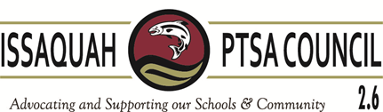
Issaquah PTSA Council Membership Meeting ISD Admin Board B & C December 15, 2016

AGENDA

9:30 Welcome Becky Gordon

9:30-9:40 Business
Minutes Leslie Kahler
Financials & Review Laila Collins
Advocacy Korista Smith-Barney

9:40-9:45 Issaquah Schools Foundation Voice Mentor Program

9:45-10:00 Best Practices Kym Clayton
Ice Breaker – Nom Com Alisa George

10:00-10:15 Gifting Funds to the District Ruby Perez -- Dir. Of Finance
Mary Beattie – District Accountant

10:15-10:30 District Updates Ron Thiele – Superintendent

10:30-10:45 Annual Community Report L. Michelle – E.D. Communications

10:45 Adjourn

11:00-12:00 Effective Meetings Ina Ghangurde
Official Training

