

Houston Kraft

Teen Kindness Advocate

─

Issaquah Middle School

600 2nd Ave SE Issaquah 98027

─

Register at

[*http: //ParentWiser.org*](http://ParentWiser.org)

─

Free for all parents of Issaquah School District

─

For parents of grades 6-12

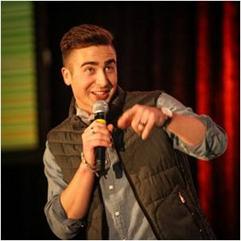

Tues, Jan 17th 6:30-7:30PM

***What young people today NEED to be successful and kind***

Do you want your teen to be kind? Helpful? Generous? Empathetic? Houston has worked with millions of young people talking about how to make their school and their lives more selfless and compassionate. Through his candid conversations and interactions, he has learned a few things about what students today NEED to be more thoughtful, successful, KIND people. In a short hour, he will help you think about character in a new way, make you laugh, and give you some practical tools to engage your teen in meaningful and powerful conversations.