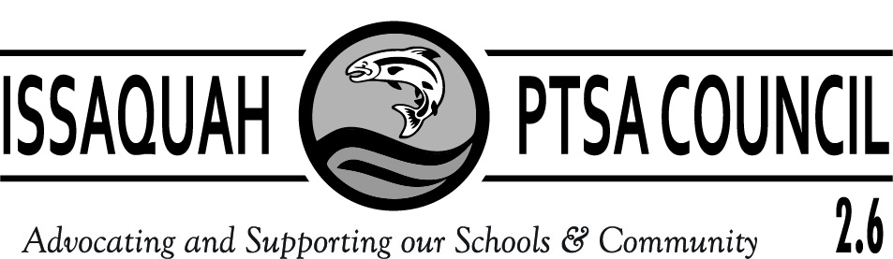

ISSAQUAH PTSA COUNCIL 2.6
COUNCIL FEES AND DONATIONS
2019 – 2020 SCHOOL YEAR

Attention Treasurers: This form details billing and Instructions for Council Fee and Donations Submissions due Oct. 31, 2019

- Issaquah PTSA Council assessment fee is collected only in October. **Note, due to a budget surplus, we have reduced fees by $100 from last year.
      - Elementary Schools $210.00
      - Middle Schools $185.00
      - High Schools $160.00

- SurveyMonkey $14.00 per PTA/PTSA.
- ParentWiser (Parent Ed) $250 Minimum per PTA/PTSA. If your PTA/PTSA budgeted more than $250 to support our new ParentWiser program, please remit the amount you have budgeted.

Make checks payable to ISSAQUAH PTSA COUNCIL 2.6 for the total of your Council fees and donations. Please be sure the check has 2 signatures!

Submit your check for the following grand total:

  - Council Fee ($210, $185, or $160) ______________
  - Survey Monkey __+___$14.00____
  - Parent Ed __+___$250.00___
  - Grand Total __=____________

PTA/PTSA Name _______________

- Mail check and this form NO LATER THAN OCTOBER 31, 2019 to:
Issaquah PTSA Council
c/o Laila Collins
17406 SE 139th Pl
Renton, WA 98059

Thank you for your prompt payments!
If you have any questions, please contact Council Treasurer,
Laila Collins, treasurer@issaquahptsa.org or 206-696-2365.

Attention Treasurers: This page is for your invoice/record.

- Issaquah PTSA Council Assessment Fee for 2019-2020:
      - Elementary Schools $210.00
      - Middle Schools $185.00
      - High Schools $160.00

- SurveyMonkey: Each year, each local PTA/PTSAs contribute to the cost of the SurveyMonkey licensing fees. This Council fee was approved at the Issaquah PTSA Council General meeting in May 2019. Each local unit should have a line item in their budget for this fee of $14.00. Please contact Council Webmaster Cindy Kelm at webmaster@issaquahptsa.org with any questions regarding this program.

- ParentWiser (Parent Ed): Each year, each local unit contributes to the funding of the Council’s district-wide parent education programs and transition seminars. Each PTA/PTSA should have a line item in their budget for this fee of $250 minimum. Please contact the Council Parent Ed Chair Heidi Fuhs with any questions regarding this program at parent-ed@issaquahptsa.org

- Total Amount Submitted to Issaquah Council PTSA by October 31, 2019

= $________

