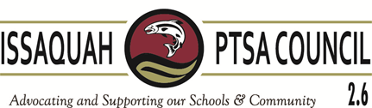
Issaquah PTSA Council Membership Meeting Pickering Barn
May 17, 2017

AGENDA

9:40-9:55 Welcome & President’s Report Becky Gordon & Leslie Kahler

9:55-10:20 Business
Consent Agenda:
Minutes (April) Erin Thacker
Financials (April) Erin Eaton
Membership Erin Eaton

Secretary Report Erin Thacker
Financial Report/2018-2019 Budget Laila Collins for Erin Eaton
Standing Rules Leslie Kahler

10:20-10:30 Vice Presidents Korista Smith-Barney, Wendy Shah,
Laila Collins, Ina Ghangurde

10:30-10:40 WSPTA
Best Practices Korista Smith-Barney
Advocacy Open

10:40-10:50 Committee Reports
Art in the Schools Juliette Ripley-Dunkelberger & Laurelle Graves F.A.C.E. Ina Ghangurde
Influence the Choice Andie Adee & Katie Moeller
Issaquah Schools Foundation Valerie Yanni
Outreach Kim Weiss & Kristen Slocum
Parentwiser Heidi Fuhs & Debbie Steinberg-Kuntz
Reflections Leah Gibson
Staff Appreciation/Echo Glen/ACT Kim Weiss, Wendy Shah, Nicole Morgan
STAR/Special Ed Carrie Hipsher
VIS Dawn Peschek
Webmaster/Directory Cindy Kelm

10:50-11:00 District Updates Doug Jones, IEA President

11:00-11:10 New Business

Adjourn for End of Year Luncheon

Upcoming Training:
WSPTA Convention, May 18-20 Vancouver, WA
ISD Admin. Building, June 7 at 10 am: Training for all incoming board members

