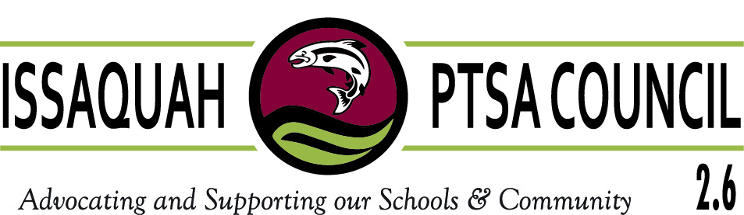
DRAFT MINUTES

Issaquah PTSA Council 2.6
General Membership Meeting
Thursday, December 15, 2016
ISD Administration Building
9:30-11:30am

Call to Order
Call to order 9:34 a.m. 31 people signed in; 15 of 24 schools were represented. Proper meeting notice was given. Quorum Present.

Minutes – Leslie Kahler
November 10, 2016 GM meeting minutes were distributed and reviewed; filed with mentioned changes. Sheet sent around collecting president changes prior to name cards being made.

Treasurer’s Report – Laila Collins
November Financial Report was distributed and reviewed. All Council dues now paid. Leslie Kahler, non-check signer, reviewed bank statement. Taxes and AIM insurance were paid by appropriate deadlines. All schools should send copy of Aim Insurance certificate to Laila Collins (get the certificate off the AIM Insurance web site; they are not mailed out). Beginning balance was $26,185.83 and ending balance was $30,731.89.

Advocacy – Korista Smith-Barney
January 16th is Focus Day in Olympia. A “What to Expect” email will be sent to presidents regarding Focus Day. Postcards were handed out to schools to complete and return to the January GM Council meeting. Korista Smith-Barney will deliver to appropriate legislators. More information is on the Council Web site under Agenda Notes.

Special Visitors –

Voice Mentor - Susan Gierke & Teresa Bretl from the Issaquah Schools Foundation
There are 392 Voice Mentors district wide, but more are needed. Each school has somewhere between 5-25 students on a wait list. Voice Mentors work at all school levels, but the majority are at elementary schools. College Core Mentors assist Seniors at the high school level with editing their Senior Essays. This work is done September through December each year. Bridges to Voice, in conjunction with Cultural Bridges, helps involve the adults in the ELL community with students needing ELL support.

Mary Beattie, District Accountant & Ruby Perez, Director of Finance
Mary Beattie explained there are two donation forms used by the district; one for donations under $5,000 and one for donations over $5,000. Before a PTA/PTSA gifts money, they should have prior approval from the principal. The school fills out the appropriate donation form, and makes the purchase. That way the items become the property and responsibility of the district. Donations above $5,000 need approval from the school board. The district will review donations to make sure the donation is consistent with programs and philosophy, has reasonable installation and maintenance costs, is free from hazard and has no direct or implied commercial endorsement. Any donations for EA funding, must also be given to the district who then does the hiring, follows proper Regulations, etc. Once the funding for the position is exhausted, the position is gone (the school district will not continue to fund it). Having the district assume responsibility for property, ensures that it is tagged and followed by the district, so the item stays with the classroom, should the teacher leave employment at that school. If the donation is for a consumable item such as paper supplies or food items, then it is acceptable for the PTA/PTSA to purchase. Teacher stipends should also be monitored somewhat by the school. Best to gift the money to school and then ask for an accounting of how the funds were spent, along with a return of any remaining funds at the end of the year.

L. Michelle, Executive Director of Communications
L. Michelle gave an overview of the Community Report, which is listed on the District web site. This report is updated each fall and reflects the previous year. It gives an overview of how students are performing, OSPI links, test scores, academics, programs and services, the district’s financial picture, the school board’s End Goals, The Ends Monitoring Report and a scorecard, which indicates the most important bench marks.

District Updates

Ron Thiele, Superintendent
- Ron Thiele further explained the scorecards discussed by L. Michelle, by explaining that specific data can be further broken down on the scorecard.
- The District is continuing its 3rd year of Equity work by undergoing additional training of administrators. Training will be extended to all teaching staff in January. The goal is to help staff be more culturally aware. 55% of the students in the district are white; while 45% are other. Teaching staff is primarily female, and white, so helping all staff become more culturally aware. The District is finding that often more culturally diverse employee candidates are not available, so the training is helping fill that gap.
- District has been involved with Riverview, Tahoma and Snoqualmie Valley school districts as part of the Center for Collaborative Study. Additional training for teachers is done online. They are using this avenue to spread Cultural Competency.
- Each year, there is a linkage meeting between the district and Council. Last year we discussed PBSES (Positive Behavior and Social Emotional Support). This year there are three Family Nights scheduled around PBSES: Each at 6:30 pm, January 18th at Pine Lake Middle School, January 19th at Issaquah Middle School and January 26th at Maywood Middle School.
- Kudos to Parentwiser and their event at Cascade Ridge and the upcoming Teen Kindness program at Issaquah Middle School.
- This year the district launched, Gibson Ek, a choice school. Applications are now open for 2017-18 school-year. 35% of the students are engaged in internships.
- We appear to be ending a 2-year hiatus with weather issues. Safety is highest priority when deciding whether or not to delay or cancel school. Have to consider all areas in the district, as partial closures within the district are not feasible. Make sure emergency contacts are up to date; for example, did have to close Maple Hills mid-day and parents must be reachable before elementary students are released. It was pointed out that parents cannot change their own information online, and if that could be fixed, it might help with this issue. If a school has to be closed mid-day, it takes about two hours to turn the whole process, so if too late in the day, cannot be done.
- The District still needs teachers, substitutes, educational assistants and bus drivers. Sometime those with a Bachelor’s Degree can be emergency certified (those without teacher credentials) to sub or in some cases, to become teachers. There are about 5,000 open teaching positions across the state; 8,000 openings expected next year.
- The District is stressing with legislators that operating under uncertainty regarding school funding is not an acceptable way to run a business. Emphasis needs to be on fixing educational funding.
- It was mentioned that during one of our recent possible weather events, the district Facebook page said to check the District web site for weather updates, and it was neglected to be updated. The District has had a policy change; in the past, if there was not mention, then all schedules were running normally. Now, the District will give periodic updates when bad weather is predicted, so that families know whether or not schedules will change. The District does try to make a call on schedule changes by 5:30 am.

Vice Presidents & Chairs
No reports or break out session were given at this meeting.

Outreach – Kim Weiss
Donations were taken from Council Board members and the general membership for the Lunch for the Break (food items/board and new or gently used books).

Webmaster – Cindy Kelm
2016-17 Directories were handed out.

Meeting adjourned: Adjourned 11:40.

WSPTA Endorsed Training – “How to Run Effective Meetings”, Ina Ghangurde
Commenced at 11 am

Submitted by:

Leslie Kahler
Secretary, Issaquah PTSA Council 2.6
lesliekahler@comcast.net

