

Amy Lang, MA

─

Cascade Ridge Elementary School

2020 Trossachs Blvd SE

Sammamish 98075

─

Register at

[*http: //ParentWiser.org*](http://ParentWiser.org)

─

Free for all parents of Issaquah School District

─

For parents of grades K-5

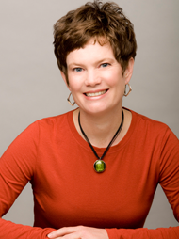

Thurs, Jan 12th 7-8:30PM

***Birds & Bees Talks for the 21st Century: Raising Kids in the Age of Technology***

The birds and the bees can be tough to talk about but with a little information, some careful thought and planning it’s possible to have comfortable and effective conversations that help your kids make safe and smart decisions on- and off-line.