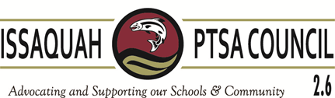
Issaquah PTSA Council Membership Meeting ISD Admin B&C November 10, 2016
AGENDA
9:30-9:35 Welcome

9:35-9:45 Guest Speaker Gena Palm, Friends of Youth

9:45-10:00 President’s Report Becky Gordon

10:00-10:10 Business
Minutes Leslie Kahler
Financials Laila Collins
Nominating Committee Becky Gordon

10:10-10:25 Breakout
Vice Presidents Kimberly Nocco, Alisa George, Care Maree Harper, Kym Clayton, Ina Ghangurde

10:25-10:35 WSPTA
Best Practices Kym Clayton & Alisa George (2)
Membership Erin Eaton (2)
Advocacy Korista Smith-Barney (2)

10:35-11:00 Committee Reports
Art in the Schools Juliette Ripley-Dunkelberger (2)
Laurelle Graves
F.A.C.E. Margarita Leas (2)
Ina Ghangurde
Healthy Youth Initiative Pat Castillo (2)
Issaquah Schools Foundation Valerie Yanni (2)
Outreach Kim Weiss (2)
Parentwiser Heidi Fuhs (2)
Debbie Steinberg-Kuntz
Reflections Yvette Blauvelt
Leah Gibson
STAR/Special Ed Carrie Hipsher
VIS Dawn Peschek (1)
Webmaster/Directory Cindy Kelm

11:00-11:15 District Updates
IEA Doug Jones
Administration Pam Ridenour – Dir. Of Counseling Services

11:15-11:30 New Business

Adjourn

