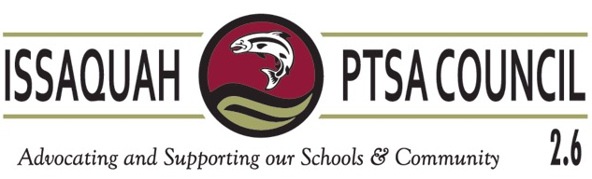

Mission & Goals 2016-2017

Strikethrough – words removed
Underline – words added

Mission:

The mission of the Issaquah PTSA Council is to empower our members as we advocate for students children at the local and state levels; build strong local PTAs/PTSAs through education and leadership support; and provide collaborative opportunities between member PTAs/PTSAs, the school district, and other community organizations concerned with the health, welfare, and education of all children.

2015-2016 version: “...at the local and state level, and to support our PTAs/PTSAs, with particular focus on helping them adopt Best Practices and develop leadership.”

Goals:

The Issaquah PTSA Council will . . .

- Make advocacy accessible for our members by providing quick and easy avenues to participate in the legislative process.
- Support local PTAs/PTSAs with their membership goals in order to increase council membership by 1.5% over last year.
- Provide Washington State PTA, National PTA, Issaquah School District, and community information to our members with active links for flyers and contact information.
- Partner with Issaquah School District to inform our members about district policies and programs.
- Educate the Issaquah School District families and community regarding the value of the Healthy Youth Survey and partner with organizations that support healthy life choices.
- Empower local PTA/PTSA leaders by encouraging the implementation of Best Practices, facilitating cooperation and information exchange, and disseminating information about state and regional leadership training.

