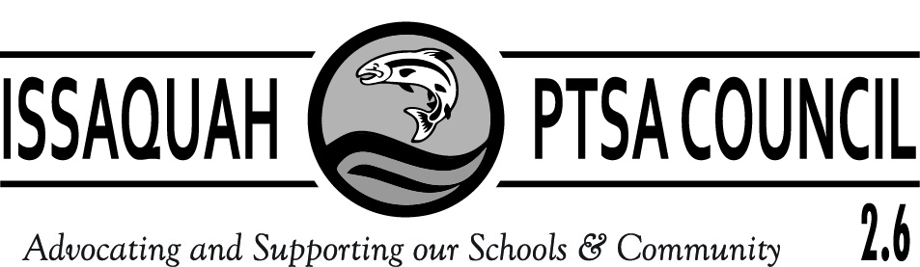

ISSAQUAH PTSA COUNCIL 2.6
COUNCIL FEES AND DONATIONS
2016 – 2017 SCHOOL YEAR

Attention Treasurers: This form details billing and Instructions for Council Fee and Donations Submissions due Oct. 31, 2016

- Issaquah PTSA Council assessment fee is collected only in October.
      - Elementary Schools $310.00
      - Middle Schools $285.00
      - High Schools $260.00

- SurveyMonkey $11.00 per PTA/PTSA.
- ParentWiser (Parent Ed) $250 Minimum per PTA/PTSA. If your PTA/PTSA budgeted more than $250 to support our new ParentWiser program, please remit the amount you have budgeted.
- Academy for Community Transition (ACT) Donation – suggested $25 - $50.

Make checks payable to ISSAQUAH PTSA COUNCIL 2.6 for the total of your Council fees and donations. Please be sure the check has 2 signatures!

Submit your check for the following grand total:

  - Council Fee ($310, $285, or $260) ______________
  - Survey Monkey __+___$11.00____
  - Parent Ed __+___$250.00___
  - ACT Donation __+____________
  - Grand Total __=____________

PTA/PTSA Name _______________

- Mail check and this form NO LATER THAN OCTOBER 31, 2016 to:
Issaquah PTSA Council
c/o Laila Collins
17406 SE 139th Pl
Renton, WA 98059

NOTE: With the opening of the new Gibson Ek High School, it is suggested that each PTA/PTSA makes a donation to aid in the startup expenses of their PTSA. The suggested donation amounts are $250 for elementary schools, $500 from middle schools, and $1,000 from high schools. Checks should be made payable to Gibson Ek PTSA and should be mailed to:
Gibson Ek PTSA
c/o Paul Dutton
PO Box 2251
Issaquah, WA 98027

Thank you for your prompt payments!
If you have any questions, please contact Council Treasurer,
Laila Collins, treasurer@issaquahptsa.org or 206-696-2365.

Attention Treasurers: This page is for your invoice/record.

- Issaquah PTSA Council Assessment Fee for 2016:
      - Elementary Schools $310.00
      - Middle Schools $285.00
      - High Schools $260.00

- SurveyMonkey: Each year, each local PTA/PTSAs contribute to the cost of the SurveyMonkey licensing fees. This Council fee was approved at the Issaquah PTSA Council General meeting in May 2016. Each local unit should have a line item in their budget for this fee of $11.00. Please contact Council Webmaster Cindy Kelm at webmaster@issaquahptsa.org with any questions regarding this program.

- ParentWiser (Parent Ed): Each year, each local unit contributes to the funding of the Council’s district-wide parent education programs and transition seminars. This fee was approved at the Issaquah PTSA Council General meeting in May 2016. Each local PTA/PTSA should have a line item in their budget for this fee of $250 minimum. Please contact the Council Parent Ed Chairs Heidi Fuhs and Debbie Steinberg-Kuntz with any questions regarding this program at parent-ed@issaquahptsa.org

- Academy for Community Transition (ACT): ACT serves students ages 18-21 from throughout our district. Donations help the ACT program fund fieldtrips and other necessities. A donation of $ 25 - $50 is suggested from each PTA/PTSA. Please contact Carrie Hipsher, Council STAR/Special Education Chair, at special-needs@issaquahptsa.org with any questions regarding this program.

- Total Amount Submitted to Issaquah Council PTSA by October 31, 2016

= $________

