- Briarwood Elementary school visit 5/4/2016
  - Coordinator: Erin Thacker
  - Lots of Picasso and ceramics today
  - 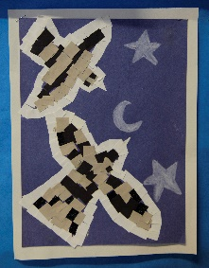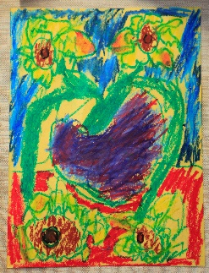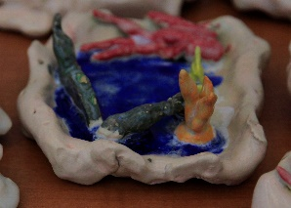
- Endeavor elementary 5/9/2016 visit
  - Coordinator: Kathy Mileski
  - 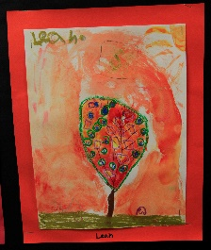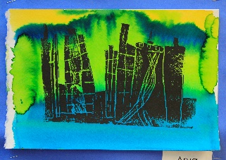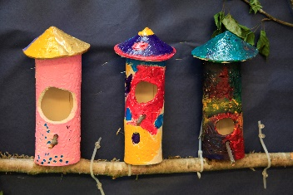
  - Well attended art walk last week
  - Lots of great art on the walls
- Challenger, Cougar Ridge, Creekside & Discovery coming up
- Trainings Winter/Spring
  - Went really well this year.
  - Ave. attendance 15 out of 20 spaces
  - Classes full (20/20) until after spring break
    - Perhaps load more classes in earlier in the year
    - No trainings after break?
- Coordinator tips:
  - Check the Facebook page for more photos and information www.facebook.com/IssaquahPTSAArtDocents/
  - Now is the time to get your last orders in for the year. Check your budgets, if you have left over order for next year now. Your PTA treasurer will close the books at the end of the school year and you start fresh next year. Budgets don’t roll over from year to year.
  - Getting information about Green Schools compliance from district
  - New lessons from Newcastle added to One Drive http://1drv.ms/1Cf5X0R

