[Type a quote from the document or the summary of an interesting point. You can position the text box anywhere in the document. Use the Text Box Tools tab to change the formatting of the pull quote text box.]

C:\Users\Gloria\AppData\Local\Microsoft\Windows\Temporary Internet Files\Content.IE5\REOHX332\MP900438769[1].jpg

**Anxiety -- Yours, Mine and Ours:**

**Finding a Way Out of the Cycle to Support Your Teen’s Success**



**ISSAQUAH PTSA COUNCIL 2.6**

*PARENT EDucation*

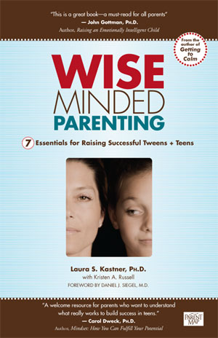

By speaker/author:

Laura Kastner, Ph.D

**Some stress is good!  Challenges energize, focus and motivate us**, building competencies and sparking new neural circuits.  The flip side is the “flooding” that can occur when demands exceed our ability to meet the challenge.  Heart rates soar, thinking clouds, brains lock and overwhelming anxiety takes over, turning our efficient survival system into an obstacle to learning and mental health.

**Stress management and resilience are key personal strengths** that can determine success or failure — especially in this "age of anxiety.”  For tweens and teens feeling the pinch of social pressures, academic competitiveness and college prep, life can become mired with one long list of stressors including school, peers, social media and family problems.

**How do parents help rather than hinder their teens’ stress management?** What is circular anxiety and do you participate in co-ruminating?  Are you worried about your teen’s grades, friendships, or risk-taking but need help finding skillful ways to address your concerns?  Do you struggle with ineffective nagging and lecturing, but feel stuck in a cycle?

**This evening’s lecture will discuss research on teen stress** and what parents can do to support their teen’s health, success and character development. Predictors of success in adolescence will be emphasized, as will parental strategies which enhance them.

**Speaker: Laura Kastner, Ph.D**

Dr. Kastner is a clinical professor in the department of Psychology as well as the department of Psychiatry and Behavioral Sciences at the University of Washington. She is the author of five parenting books, numerous published academic articles and many news articles related to child-rearing. She also has a private practice in which she sees children, couples and families. For more information, refer to [www.laurakastnerphd.com](http://www.laurakastnerphd.com)

*For more information about this event, please contact* [*parent-ed@issaquahptsa.org*](mailto:parent-ed@issaquahptsa.org)

Issaquah High School PTSA

**Dates:**

Tuesday, March 8th

7:00pm

**Location:**

Issaquah High School

Theater

700 2nd Ave SE

Issaquah WA 98027

**Cost:**

Free

*proudly sponsored by*

*IHS PTSA and*

*Issaquah PTSA Council 2.6*