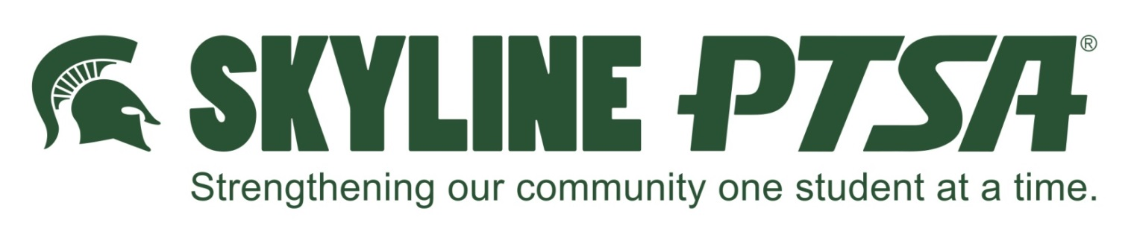

Presents

**Safe Dating – Talking to Your Teen**

Parent Seminar

**January 19, 2016 at 7:00pm**

**Skyline High School Library**

Parents often talk with their children about the dangers of drinking or doing drugs. Yet many don’t know how important it is to also talk about healthy dating relationships.

*Do you know the warning signs of an abusive relationship?*

Dating is a normal part of growing up for many adolescents. Unfortunately, one out of three teens experience some form of abuse in their romantic dating relationships – including verbal, emotional, or physical abuse.

*More than one-in-three 11-12 year olds (37%) say they have been in a boyfriend/girlfriend relationship.*

Talking to your teen early is the most important step a parent can take to ensure that when they start dating, they clearly understand what a healthy relationship involves.

*Both sons and daughters need to know what makes*

*a healthy relationship.*

*Safe Dating – Talking to Your Teen* helps parents learn more about teen dating abuse and gives parents the tools they need to discuss it with their teens. Specifically, parents will learn:

* The dynamics of dating abuse
* How to create a comfortable environment for discussing the topic
* How conversations should specifically cover
  + What to expect from a respectful boyfriend/girlfriend
  + What is affirmative consent
  + Relationship boundaries that should be in place
  + Red flags and warning signs of potentially abusive behavior
  + How to avoid or leave an abusive relationship

Every teen deserves, and has the right to, a safe and healthy dating relationship.

*Parents Make the Difference!*